**Unit 4 - Balanced Forces**

**Table of Contents**

**Instructional Goals** 4

**Student Learning Objectives** 4

**Overview** 5

**Sequence** 7

Activity 1 — Broomball 8

Purpose 8

Apparatus 8

Pre-Activity Discussion 8

Activity Performance Notes 9

Post-Activity Discussion 9

Class Discussion — Force Identification and Notation 10

Resources 10

Apparatus 10

Discussion Notes 10

Demonstration — Forces on an Air Puck 11

Apparatus 11

Performance Notes 11

Reading 1 — Types of Forces and Force Representation 13

Resources 13

Worksheet 1 — Force Diagrams 13

Resources 13

Reading 2 — Force Diagram and System Schemas 13

Resources 13

Activity 2 — Ball-Sand-Fan Simulation 14

Resources 14

Activity 3 — Air Hockey Table 18

Resources 18

Worksheet 2 — Air Hockey Table Analysis 19

Resources 19

Activity 4 — Pairs of Forces 20

Resources 20

Apparatus 20

Pre-Activity Discussion 20

Activity Performance Notes 20

Post-Activity Discussion 21

Worksheet 3 — Pairs of Forces 21

Resources 21

Lab 1 — Gravitational Force vs. Mass 21

Apparatus 21

Pre-Lab Discussion 21

Performance Notes 22

Post-Lab Discussion 22

Class Discussion — The Relationship Between Mass and Weight 22

Resources 22

Lab 2 — Friction Force 22

Resources 22

Apparatus 23

Pre-Lab Discussion 23

Performance Notes 24

Post-Lab Discussion 25

Worksheet 4 — Friction Force 25

Resources 25

Worksheet 5 — Forces in Equilibrium 25

Resources 25

Activity 5 — Rocket Lander Game 27

Resources 27

The Model So Far 27

**Resource Index** 28

Unit 4 Reading 1: Forces 29

Unit 4 Worksheet 1: Force Diagrams 32

Unit 4 Reading 2: Force Diagrams 38

Unit 4 Activity 2: Ball-Sand-Fan Simulation 42

Unit 4 Activity 3: Air Hockey Table 44

Unit 4 Worksheet 2: Air Hockey Table Analysis 45

Unit 4 Activity 4: Pairs of Forces 47

Unit 4 Worksheet 3: Pairs of Forces 53

Unit 4 Lab 2: Friction Force 58

Unit 4 Worksheet 4: Friction Force 60

Unit 4 Worksheet 5: Forces in Equilibrium 62

Unit 4 Activity 5: Rocket Lander Game 65

Function Design with Conditionals 66

# **Instructional Goals**

**1.** **Newton's 1st Law (Galileo's thought experiment)**

* Develop the notion that a force is required to *change velocity*, not to *maintain motion*
* Constant velocity does not require an explanation

**2. The Concept of ‘Force’**

* View force as an interaction between an agent and an object
* Choose system to include objects, not agents
* Represent an interaction between object and agent as resulting in a pair of forces equal in magnitude but opposite in direction

**3. Force Diagrams and System Schemas**

* Represent the interactions between system and surroundings using system schema
* Correctly represent forces as vectors originating on object (point particle)
* Use the superposition principle to show that the net force is the vector sum of the forces

**4. Statics**

* Identify that ΣF = 0 produces same effect as no force acting on object

**5. Resistive Forces**

* Distinguish between static and kinetic friction
* Calculate static and kinetic friction

**6. Computational Representations**

* Modify and create programs that represent the application of force to an object as incremental changes in its velocity
* Use displays of dynamic images of arrows to represent force vectors
* Create conditionals to represent the motion of an object as a piecewise function

# **Student Learning Objectives**

BF1: I can represent the interactions within a system or between a system and its surroundings using a system schema.

BF2: I can identify the types of forces acting on a system and their relative strength.

BF3: I can represent the forces acting on a system with a quantitative force diagram.

BF4: I can use the change in velocity of a system to determine if forces are balanced.

BF5: I can determine the conditions necessary for a force to act as expected and construct a function that applies these conditions.

BF6: I can compute the gravitational force that acts on an object using its mass and the gravitational field strength.

BF7: I can represent friction mathematically and use it to explain the behavior of objects.

# 

# **Overview**

In this unit, students are introduced to the first half of Newton's Modeling Cycle:

a) From motions (read: changes in velocity), infer forces

b) From forces, deduce changes in motion

Changes

in Velocity

Forces

infer

deduce

We are moving from the realm of *descriptive models* (kinematics) to that of *causal models*: dynamics.

"The dynamical laws connect interactions with kinematics and so determine the particle motions. The subtle, almost superfluous, role of Newton's First Law should be noted. A *free particle* is defined as one on which the sum of the forces on the system is zero (ΣF=0). This provides a criterion distinguishing inertial systems from other reference systems, and to say that free particles have constant velocities is to say that they define a uniform time scale. The definition of this time scale is an essential prerequisite to Newton's Second Law. The First Law has been previously classified as a kinematical law, but here it is classified as a dynamical law because it is an essential prerequisite to the Second Law and it involves the concept of force."[1]

It is essential for students to recognize that a system with constant velocity differs from one with non-constant velocity, and that only *changes* in velocity require an interaction between an agent and an object. We define this interaction as the concept of *force*. After the broom ball pre-exploration, students will get the sense that force is required to change the motion of an object. This is reinforced by Activities 2 and 3, and one can use worksheets 2 and 3 as an opportunity to apply the force concept in a *qualitative* way. It is important to carefully treat how to go about drawing force diagrams in which one represents the object as a point particle. In this unit, we will introduce the concept of the identification of systems and will do so by drawing dotted lines around the system being studied to help students distinguish between the object/system and the agent(s) that affects its motion. Significant attention will also be paid to identifying forces based on the type of interaction, the system, and agents involved in the interaction. This care in building the idea of a *force as an interaction* will pay large dividends when Newton’s Third Law is introduced in Activity 4.

Some students may notice the connection between the magnitude of the acceleration of a freely falling object (end of unit 3) and the gravitational field strength. Postpone discussion of this connection until Unit 5 (Unbalanced Forces) in which we will quantify the relationship between force, mass, and acceleration. This way students are more likely to understand the *g* in the *Fg* = *mg* equation as the *gravitational field strength* (desirable) as opposed to the quite different concept of the *acceleration due to gravity*, whose magnitude just happens to be the same.

Students will practice drawing simple force diagrams which require no vector components, and using those diagrams, the equation for equilibrium ($\sum{\overset{⃑}{F}}=0$), and *Fg* = *mg* to write the equations that will allow them to solve for unknown forces.

This unit will also introduce a method for determining the expressions for both static and kinetic friction. We will determine that friction is a function of the force between the surface and the object moving across it, but not the area of the contact, and that there are dramatic differences between the static case and the kinetic case.

When students have gained confidence representing forces and their effects on system motion without the use of vector components then further mathematical treatments can be considered. In this introductory course, we choose not to decompose force vectors using trigonometry. However, it is important to expose students to qualitative analyses of such problems, as not all forces act parallel to the coordinate axes. Additional treatments are offered as supplemental resources for this unit.

# **Sequence**

1. Activity 1 — Broomball
2. Class Discussion — Force Identification and Notation
3. Demonstration — Forces on an Air Puck
4. Reading 1 — Types of Forces and Force Representation
5. Worksheet 1 — Force Diagrams
6. Reading 2 — Force Diagram and System Schemas
7. Activity 2 — Ball-Sand-Fan Simulation
8. Activity 3 — Air Hockey Table
9. Worksheet 2 — Air Hockey Table Analysis
10. Activity 4 — Pairs of Forces
11. Worksheet 3 — Pairs of Forces
12. Lab 1 — Gravitational Force vs. Mass
13. Class Discussion — The Relationship Between Mass and Weight
14. Lab 2 — Friction Force
15. Worksheet 4 — Friction Force
16. Worksheet 5 — Forces in Equilibrium
17. Activity 5 — Rocket Lander Game
18. The Model So Far

## Activity 1 — Broomball

### Purpose

The purpose of this activity is to give the students in your class a common experience from which to commence force concepts.

### Apparatus

* Broom with flexible bristles and a plastic casing at the top of the bristle end (You can find these brooms at the dollar store)
  + *Long-handled rubber mallets can be used in place of brooms as needed.*
* Bowling ball
* Large pail containing sand
* Course marked off with tape on the floor (see diagram below). *Teacher note: blue painters’ masking tape or electrical tape works best for tape removal after the activity.*

Pail

### Pre-Activity Discussion

The rules of the game:

* Play BroomBall as a relay race.
* Divide the class into two teams. Place half of the team at each end of the course.
* The bowling ball should be at rest at one end of the course. Each student will run the course from whichever end they are.
* The ball may be manipulated only with the bristles of the broom. If any part of the broom other than the bristles touches the ball that is a penalty. If the ball touches any obstacle in the room (furniture, a student’s foot, etc.) that is a penalty.
* Start the clock when the first player takes off. The student should follow the course. They must go all the way around the large pail (360 degrees), through the no touch zone without touching the ball with the broom, around the corner and bring the ball to a complete stop in the starting box, before the next player takes off reversing the course.
* After the last team member has completed the course, stop the watch and add a second for each penalty while the ball was in play.
* The team with the shortest time wins. You decide the reward.

### 

### Activity Performance Notes

Select members of the opposite team to help with timing, but make sure that you as teacher determine all of the penalties. To eliminate arguments, give the guilty team 5 penalty points.

### Post-Activity Discussion

After the game is over and the winning team commended, ask the students what was challenging about BroomBall. Ask only for *difficulties* with the ball. Then ask them what broom remedies helped overcome those difficulties. Make a list of each on the board. Your students might mention:

* Difficulties
  + Starting
  + Stopping
  + Changing direction
* Broom Remedies
  + Pushing the ball from behind
  + Pushing the ball from the front/placing the broom on top of the ball
  + Pushing the ball from the side, or at 90 degrees to the direction of the motion

It is important that students determine that the force they applied and the change in velocity are *always* in the same direction. **If the force is continuously applied in the same direction as the existing velocity, the velocity will increase. If the force is applied in the opposite direction, however, the velocity decreases.**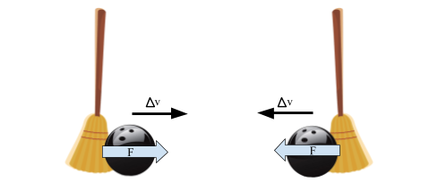

## 

## Class Discussion — Force Identification and Notation

### Resources

* “What Is a Force?” - Veritasium <http://www.youtube.com/watch?v=GmlMV7bA0TM>

### Apparatus

* Ramp
* Wooden ball
* Steel ball
* 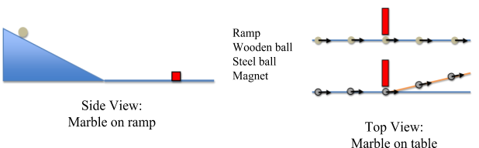Magnet

Use a ball on ramp to create a constant velocity along the tabletop for a rolling ball. The wooden ball rolls past a magnet and continues to travel in a straight line. The steel ball rolls past a magnet and is pulled ‘off path’ with a slight change to the path.

### Discussion Notes

Focus the discussion on the motion while the balls are rolling on the table.

* Why are the balls moving at constant velocity on the table?
* Is the Earth still acting on the balls?
* If the Earth is still acting on the balls, then why don’t they change velocity (vertically)?

[The table acts on the ball, with a force called ‘normal’. It is recommended to use the term ‘perpendicular’ as well and using the symbol “⊥” to denote the ‘Normal’ force, to help the students recognize the direction it acts.]

Finally, focus on a book sliding across the table. Why does the book not travel at a constant velocity? [The table acts on the ball, with a force called ‘friction.’]

Following the discussion, students should watch “What is a Force” via the Veritasium YouTube channel.

**Teacher’s Note:**

*For this unit, as in the units addressing unbalanced forces and momentum, the notation “Fg” is the only variation addressed. When calculating the gravitational force using the Universal Law of Gravitation, we will use “FG.”*

|  |  |  |  |
| --- | --- | --- | --- |
| ***Fundamental Forces*** | | | |
| **Gravitational** | **Electromagnetic** | **Strong\*** | **Weak\*** |
| Gravitational (g)  *Note:*  *Fg will be used throughout these materials to denote a constant gravitational force and FG will be used for the gravitational force as calculated using the universal law of gravitation.* | Friction (f) |  |  |
| Normal (N) *or*  Perpendicular (⊥) |
| Tension (T) |
| Electrostatic (elec) |
| Magnetic (M) |
| Push/Pull (P) *or* Applied (A) |

*\*The strong and weak forces complete the list of fundamental forces but are beyond the scope of this course.*

## Demonstration — Forces on an Air Puck

### Apparatus

* Hover Puck, air table, or block of dry ice
* large level table, clean tile floor. or large (4’ x 4’ or larger) flat whiteboard (if using hover puck or dry ice)
* gloves (if using dry ice)

### Performance Notes

The naive belief that forces are properties of objects and that forces are carried along with objects, perhaps wearing out over time or distance, is a persistent belief reminiscent of the pre-Newtonian teachings about “impetus.” The presence of impetus assures an on-going motion; its disappearance will result in an object coming to rest. An indirect goal of this activity is to provide students an opportunity for arguing that a free particle, i.e., one subject to a zero sum of the forces, will have a constant velocity. Also, students should conclude that any apparent change in velocity of an object indicates that a non-zero sum of the forces is acting upon it, provided that the observer is in an inertial (non-accelerating) frame of reference.

*The use of “sum of the forces” and ΣF rather than “net force” and Fnet is established to reinforce that the net force is not a force separate from the gravitational and electromagnetic forces acting on the object but rather the result of the summation of the forces acting on the object.*

Where possible, depending on which apparatus you use, you will want to demonstrate each of the following situations:

1. Object at rest on a level surface—air source turned off.
2. Object at rest on a level surface—air source turned on.
3. Object in motion on a level surface—negligible friction.
4. Object in motion, being pushed in the direction it is moving.
5. Object in motion, being pushed in the opposite direction it is moving.
6. Object in motion, being pushed perpendicular to the direction it is initially moving on a level surface.
7. Object in motion, being pulled perpendicular to the direction it is moving at all times.
8. Object in motion on a level surface for which friction is not negligible.
9. Object on inclined surface—negligible friction.

One way to apply a constant force to an object is to attach a rubber band to it and to pull the object while keeping the rubber band stretched a constant amount. Another very nice way to apply a constant force is to push the object with a strong stream of air such as one from the output of a shop vacuum or from a leaf blower. The nice thing about the air stream method is that it can be used to apply fairly constant forces or to provide quick impulses. *(The term ‘impulse’ is being used here for clarification purposes for instructors but* ***should not*** *be used with your students at this time. Impulse will be discussed in a later unit.)* You can purchase dry ice at many local supermarkets. Two to three pounds will last through the day if kept in a cooler. Get pieces that have a smooth surface and are at least 2" thick.

To prepare the dry ice:

* With a cordless drill you can firmly attach a drywall screw into the block.
* Make the bottom surface as smooth as possible by rubbing it with fine sandpaper.
* If the table is level, the block should remain motionless, floating on a layer of sublimed CO2. Given an impulse, the block will undergo uniform translational motion until someone catches it before it falls off the table. You and student helpers can play catch with the sliding block.
* Make the point that when no force acts on the block in the horizontal direction, the block maintains constant velocity.
* Point out that an impulse applied perpendicular to the original trajectory does not result in the block making a right-angle turn.
* Be sure to ask why they think the block continues to move once it leaves the hand. Some are likely to answer "… due to the force of the hand."
* Attach a rubber band to the screw in the top of the block. Apply a constant force by keeping the rubber band stretched a constant amount. The block clearly accelerates.

Student conclusions should be clear: in order to change the velocity (speed *and/or* direction), a force must be applied; in all of these cases, the force is a contact one.

Goals:

* Develop ΣF = 0 (for constant velocity) & ΣF ≠ 0 (for non-constant velocity).
* Draw a ‘force diagram’ for each motion and situation but leave sharing the name of the diagrams until the concept above is fully developed.

## Reading 1 — Types of Forces and Force Representation

### Resources

* Unit 4 Reading 1: Forces

At this time, it is only the type of force and its representation that will be emphasized. Following the second activity, the connection between system schema and forces will be emphasized to allow students to diagram interactions between objects and add agent-object notation to force subscripts.

## Worksheet 1 — Force Diagrams

### Resources

* Unit 4 Worksheet 1: Force Diagrams

For each system on this worksheet, students are asked to fill in a table, drawing a system schema and a force diagram for each object or system. The table also asks students to establish sign conventions (up = positive; right = positive), write sum of forces equations for both the horizontal and vertical forces, and define the subscripts used for each force.

## Reading 2 — Force Diagram and System Schemas

### Resources

* Unit 4 Reading 2: Force Diagrams

This reading adds system schemas and agent-object notation to add to the previous representations of force.

Previously used to show the transfer of energy between objects within a system or between a system and its surroundings, system schemas can be used to diagram the interactions between objects prior to constructing a force diagram.

For example:

Agent-object notation adds two additional subscripts to each notation of force acting on an object. The first subscript names the type of force acting on the object, the second one is the “agent” or “dealer” of the force, the thing outside the system producing the force. The third subscript is the “object” or “feeler,” in other words the object or system experiencing the force.

$${\overset{⃑}{F}}_{type by Agent on Object}$$

## Activity 2 — Ball-Sand-Fan Simulation

### Resources

* Unit 4 Activity 2: BallSandFan Simulation
* Student Code: <https://tinyurl.com/U4-Ball-Sand-Fan>
* Function Design: Function Design with Conditionals

This worksheet introduces students to the addition of conditionals to their functions. The graphics and scenario here reference the activity that follows, Activity 2: Ball-Sand-Fan.

The starter code includes:

**fun** force-status(sand-force, fan-force):

"unknown"

**end**

When clicking ‘RUN’, the position dot diagram shows up with black dots. Students should be directed to use the dot placement to create a motion map for the ball. After constructing a motion map for the motion of the ball, students should whiteboard this so the boundary conditions can be brought forth as part of a discussion. The focus is on the *sum of the forces*, not the individual forces themselves. Ask students to recall the Broom Ball activity, in which it was determined that the sum of the forces and the change in the velocity are always in the same direction. Their motion map should show that when the ball is on the grass and pushed by the wind from the fan, it accelerates to the right. This means that the sum of the forces is also to the right, or positive since the labeled positions indicate that rightward is the positive direction. The motion map should also show that when the ball rolls through the first patch of sand it slows down, meaning the acceleration is to the left and that the sum of the forces is as well. When the ball rolls through the sand but is also pushed by the fan, it will not accelerate if the sum of the forces is zero.

Have students label the areas of the motion map with $\sum{\overset{⃑}{F}}=0$, $\sum{\overset{⃑}{F}}>0$ and $\sum{\overset{⃑}{F}}<0$ as appropriate. The sum of the forces can be expressed as the sum of sand-force and fan-force, making these areas in which sand-force + fan-force = 0, sand-force + fan-force > 0, and sand-force + fan-force < 0. Students should then recognize that if the sum of the forces is zero the forces are balanced, if the sum is greater than zero the forces are unbalanced to the right, and if the sum is less than zero the forces are unbalanced to the left.

Conclude this discussion by completing the function design for the function sum-of-forces. Note: all examples must include proper sign conventions, specifically about the direction of the sand-force. The sand-force acts opposite the direction of the motion, so when the v-init value is chosen to be positive, the sand-force input in the examples block must be ‘negative’, and vice versa.

When writing the conditional, students should be directed to use the three expressions they just wrote on the motion map. If an expression returns true, what is the status of the forces during that portion? The program reads each in order and will stop evaluating once one expression returns true.

**fun** sum-of-forces(sand-force, fan-force):

sum = sand-force + fan-force

**if** sum < 0: “unbalanced left”

**else if** sum > 0: “unbalanced right”

**else:** “balanced”

**end**

**end**

As the ball travels across the screen, a position dot diagram is created (not a true motion map). *The position appears as a gray dot when the forces are balanced (sum of forces = 0), a red dot when the sum of the forces is directed rightward (positive) and a blue dot when the sum of the forces is directed leftward (negative).* (The motion map displays ‘black dots’ if the program doesn’t get an expected output for the expected string outputs.) The connection between the direction of the sum of the forces and the direction of the change in velocity should be once again emphasized, and that the color code is based on the DIRECTION of the change in velocity, not whether the ball is speeding up or slowing down. (This is non-trivial.)

The simulation begins by assuming that the ball has an initial rightward velocity. Students can change this to start with an initial leftward velocity, which may conflict with the conditional in their sum-of-forces function. This is an exercise definitely worth working through with students in order to highlight the distinction mentioned above regarding the color coding for unbalanced-left vs. unbalanced-right, and those expressions *not* being related to ‘speeding up’ and ‘slowing down’ directly.

The position dots produced by the simulation are color-coded according to the following key:

* “unbalanced right” should produce RED dots.
* “unbalanced left” should produce BLUE dots.
* “balanced” should produce GRAY dots.
* BLACK dots means that the program doesn’t recognize your string output. (Check spelling)

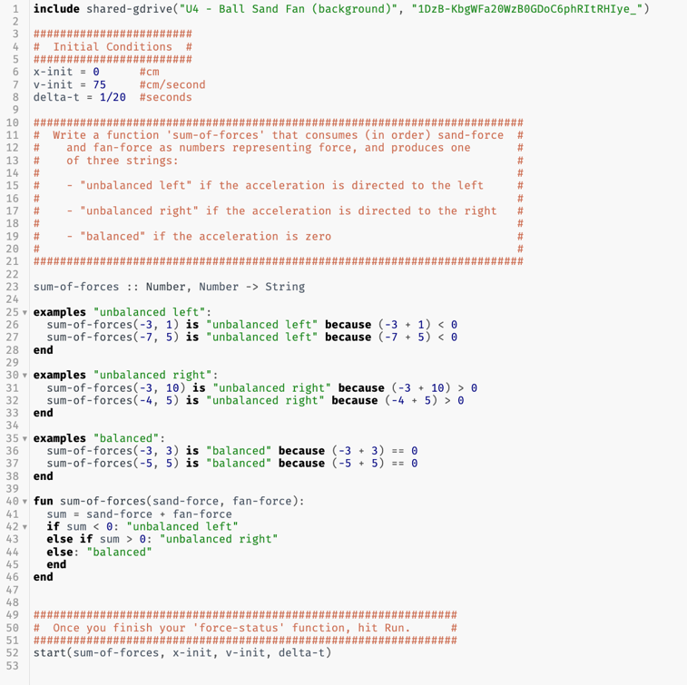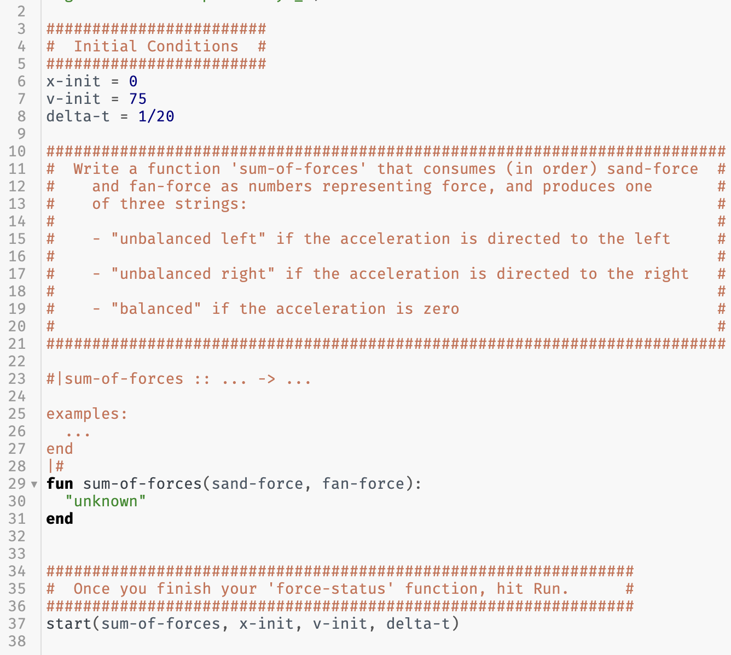

NOTE: The dots do NOT mean ‘speeding up’ or ‘slowing down,’ as those are determined based on the motion of the object at that moment, not the direction of the unbalanced force. Furthermore, the dot positions are *not* dependent on the student codes, only the colors associated with the state of the sum of forces (“unbalanced left”, “unbalanced right” or “balanced”). In the case where the ball moves to the left, be sure to check the COLORS of the dots to confirm that the student code is correctly identifying the direction of the unbalanced force. Many students will do a comparison for their code (e.g., **if** sand-force < fan-force: “unbalanced right”), but this will not produce the expected outcomes. In the case of leftward moving motion, because the magnitudes of the forces are equal, the dots will likely be colored ‘gray’, the color of the balanced condition, yet the motion clearly shows different spacing between the dots. By very carefully selecting the initial velocity to the left, you can have the ball change direction and roll back to the right again, to confirm that the conditionals were written correctly. This is an exercise well worth the time.

Reactor Output, when correct for an object moving to the right…

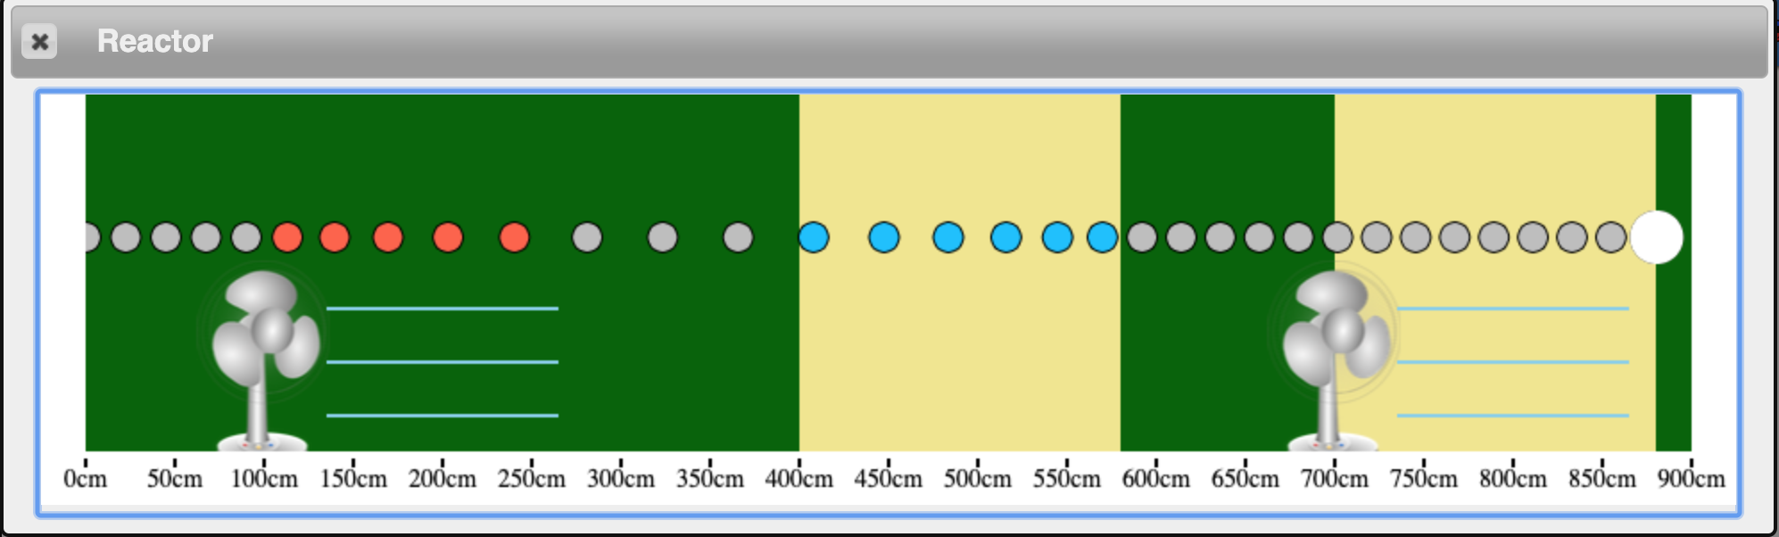

Reactor Output, when correct for an object moving to the left…

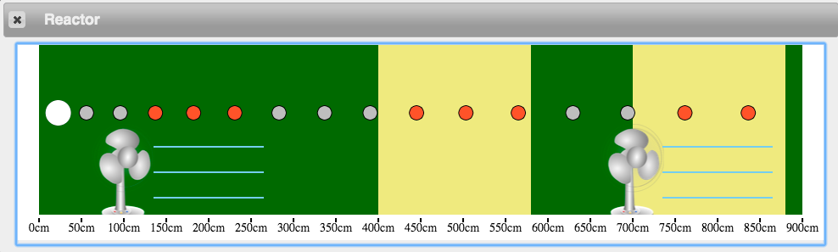

The examples blocks for this function will return feedback. When written, the right side of the example is a string and the explanation returns a Boolean value. Since a string cannot be equal to a Boolean value, students will receive feedback as shown below. Note that the Boolean value returned here is true, hopefully indicating that the explanation uses an expression that matches the string on the right side.

## Activity 3 — Air Hockey Table

### Resources

* Unit 4 Activity 3: Air Hockey Table
* Student Code: <https://tinyurl.com/U4-Air-Hockey>

This simulation shows a puck moving across a broken air hockey table. The students’ goal for this simulation is to keep the puck moving at a constant velocity even as it passes into the broken half. 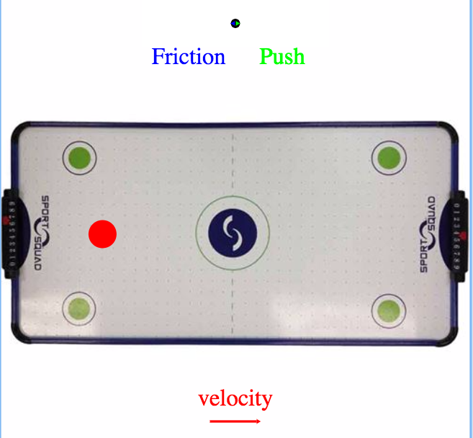

*NOTE: The space bar works as a ‘pause’ button for the simulation.*

The left side of the broken air hockey table is working fine (frictionless), but the right side has friction. The frictional force has been pre-programmed and students must decide how to keep the puck moving the entire time, as if the air hockey table were working (*meaning at a constant velocity*).

The force vectors above the table are present (the pre-programmed friction is shown in blue, and the student-programmed push is shown in green) as is the instantaneous velocity vector below the table.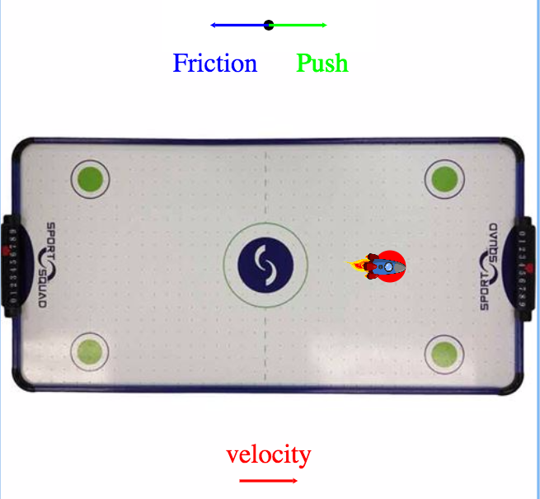

Students should first program a value for the push, run the program, and then observe the relative size of the vector. Their goal is to determine a value for the push that will result in a zero sum of the forces.

Questions students should consider during this stage of the activity:

* How much force must act on the red puck?
* When is the force acting on the puck?
* In what direction must the force act on the puck?
* How do we tell Pyret to only have the force act once the puck passes the midway point?

Discussion ideas following this stage of the activity:

* We get the puck to continue moving in the same direction if it was *hit* in that direction.
* In each stage the force causes a change in velocity, which is an acceleration, thus there is a connection between force and acceleration.

Students should use the OUTPUT table after the simulation runs to help guide their thinking. Again, the examples blocks will not pass tests since we are asking to equate two different data types, a Number and a Boolean value. Students should be directed to use this feedback to verify their conditionals block.

Student Code: Sample Solution:

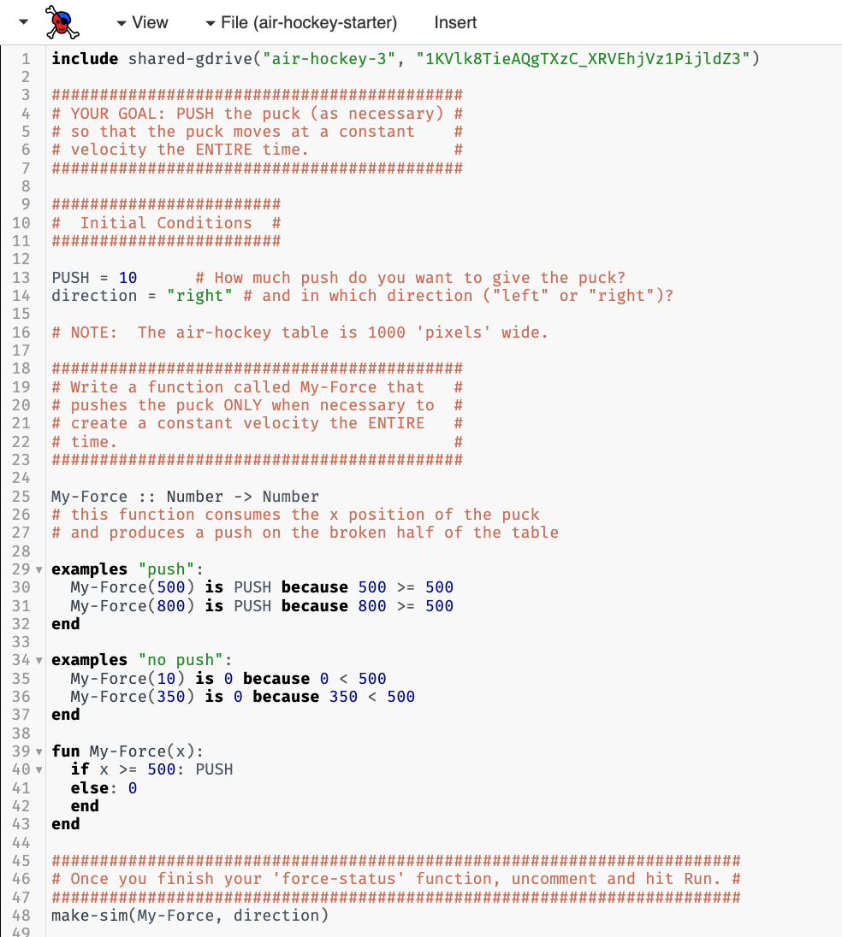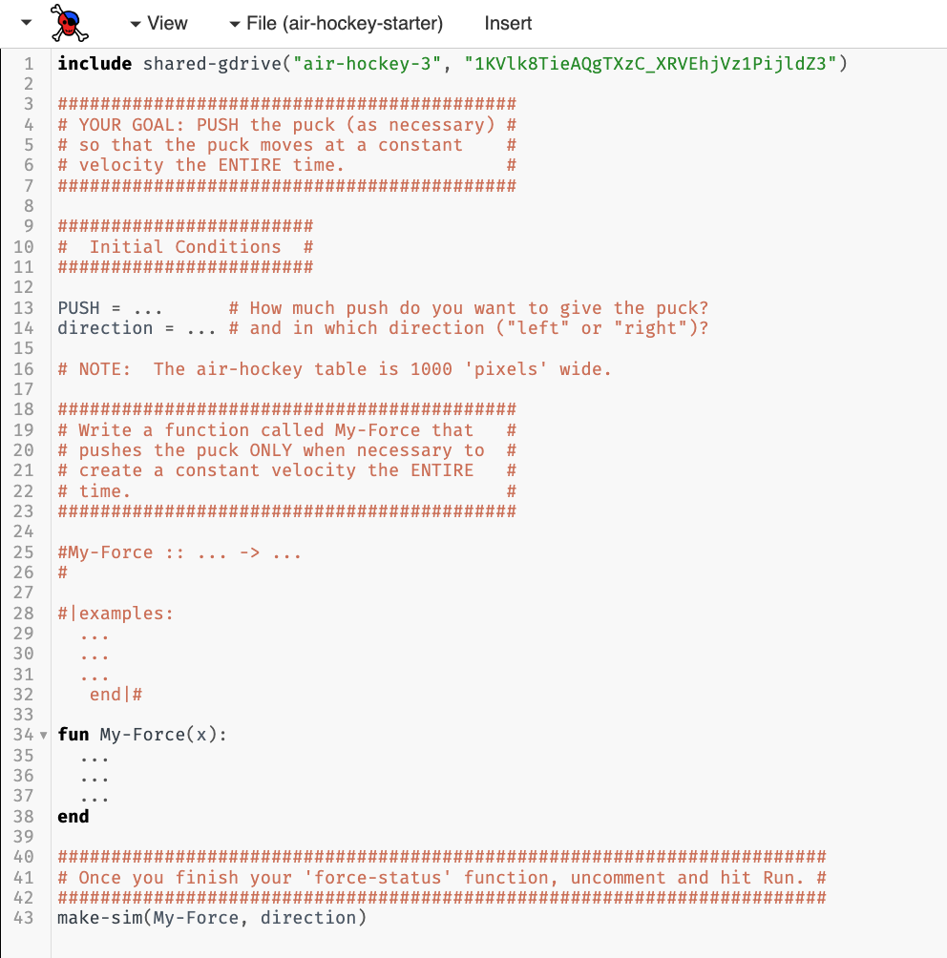

## 

## Worksheet 2 — Air Hockey Table Analysis

### Resources

* Unit 4 Worksheet 2: Air Hockey Table Analysis

The goal of this worksheet is to highlight learning objectives demonstrated in the Air Hockey simulation:

* Forces happen only as an interaction between objects.
* Forces act in specific directions, based on the type of interaction and the orientation of the scenario.
* When the object has constant velocity, students can deduce the forces are balanced ($\sum{\overset{⃑}{F}}=0$).
* When an object has non-constant velocity, students can deduce the forces are unbalanced ($\sum{\overset{⃑}{F}}≠0$).

## Activity 4 — Pairs of Forces

### Resources

* Unit 4 Activity 4: Pairs of Forces

### Apparatus

* One pair of force sensors
  + *Spring scales could be used instead of force sensors, focusing solely on the “pulling” forces.*
* String
* Rubber band
* Masses
* Dynamics carts
* Dynamics track
* Magnets (one pair)

### Pre-Activity Discussion

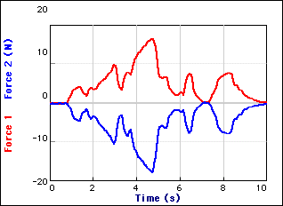This lab consists of several scenarios in which students will examine the pair of forces between two objects. In each, students will use a pair of force sensors to measure the force exerted by object A on object B, and vice versa.

Begin by having two students stand facing one another. Ask them to place their palms against one another and push. Ask: Who pushes more? How do we know? Ask students to construct a system schema, treating the students as two separate objects, and label the forces involved.

Focus student attention on the SINGLE interaction (force) between those two students/objects. Contrast this against the use of all the forces acting on a single system. Rather than focusing on all the interactions on one object, focus on a single interaction from both sides. So, we focus on the force on object 1 from object 2, and vice versa, instead of all the forces acting on object 1.

### Activity Performance Notes

Before beginning this activity, care should be taken to zero the force sensors, and change the direction on one in each pair. This will define one of the force sensors as ‘push’ positive, and the other as ‘pull’ positive. The full activity provides more than sufficient data to convince students of Newton’s 3rd Law, but only if the notation is clear and the force sensors are properly calibrated.

In every scenario, students should produce a graph similar to what is shown. Be sure that the graph shows the same. Ultimately, this will support the transition to investigating Newton’s 3rd Law.

In all cases, regardless of the circumstances, students should see that the force on 1 on 2, is equal and opposite to 2 on 1.

### Post-Activity Discussion

Point the attention of the students to the system schema. Highlight that this is a single interaction, one that is the same strength for both objects for *all times*. A common student misconception is that, if two objects are accelerating, then one must exert more force on the other. If students did not investigate this in the activity, do so during discussion. Focus their attention again on the system schema and highlight the single interaction between two objects.

## Worksheet 3 — Pairs of Forces

### Resources

* Unit 4 Worksheet 3: Pairs of Forces

This worksheet reinforces the idea that Newton’s 3rd Law pairs are the result of one interaction between two objects. System schema and force diagrams using agent-object notation are used to represent this concept.

## Lab 1 — Gravitational Force vs. Mass

### Apparatus

* Spring scale or force sensor
* Mass hanger and lab masses sufficient to allow 6 data pairs within range of scale (probe)

### Pre-Lab Discussion

The purpose of this experiment is to develop a mathematical representation to describe the effect of the gravitational field on matter.

* Hold an object above the table and let it go. Ask students what force(s) act on the object. Most, no doubt, will answer, "gravity." It's worthwhile to spend some time defining gravity as a long-range force exerted by one body (in this case, the Earth) on another. Ask students to identify the characteristics of some object that affects the force of gravity on it.
* While the mass of the object is the only significant characteristic, many others will be mentioned. Among other nominations may be air pressure, the height of an object above the floor, the object’s weight, etc.
* Ask what variables might be measured. Foster a consensus that the force of gravity and the mass are the significant variables and that they may be measured. Don't rush through this, however, as there's evidence that many students have a poorly formed concept of gravity. (See [*Heavy Boots*](http://www.phys.ufl.edu/~det/phy2060/heavyboots.html))
* This is the first encounter with measuring forces. We simply grant that spring scales or force probes measure what we mean by “force” and that the unit we use for measurement is the Newton (N).

### Performance Notes

* Students will measure the force of gravity on various objects using spring scales. The masses of the objects can be measured by balances. It may be interesting to have a mislabeled mass, i.e., one that has a real mass different from the value stamped onto it.
* An alternative is to suspend a cup from the spring scale and to fill the cup with varying amounts of sand, determining its mass using a balance and the force of gravity using the spring scale.
* Groups will generate graphs of **Fg by E on m** vs. **m**.

### Post-Lab Discussion

* The equation of the regression line should be **Fg by E on m** = (9.8 N/kg) **m**
* Students can interpret the slope of the **Fg by E on m** vs **m** graph. We will call the slope “**gfs”**, the *gravitational field strength* of the Earth. Students will doubtless see a connection between the acceleration of an object in free fall (aka, “Galileo’s constant”) and **gfs**. It is important to emphasize *gravitational field strength*, with units of N/kg since this value was measured as a relationship between gravitational force and mass on a stationary object. Here we introduce the field concept that underlies electrical and magnetic fields, too. At this point, one could introduce "weight" as the common name for the force of gravity, but we recommend trying to steer clear of the term “weight”, because of the confusion with mass.

## Class Discussion — The Relationship Between Mass and Weight

### Resources

* Veritasium – Mass vs. Weight <http://www.youtube.com/watch?v=_Z0X0yE8Ioc>

Students often confuse the *mass* of an object with the *weight* of the object. Following the gravitational force vs. mass lab, it is important to ensure the distinction is made, and that students understand that *weight* and *gravitational force* are synonymous. The goal should be for students to use the term *gravitational force* as it is more specific and less ambiguous.

## Lab 2 — Friction Force

### Resources

* Unit 4 Lab 2: Friction Force

Some teachers may feel the need or be inclined to go through friction with a bit more detail than the treatment we have given to it up to this point. The development of the idea that constant motion features balanced forces allows us to perform this lab now. In doing so, students will get more practice in using a force diagram quantitatively.

### Apparatus

* Wooden Blocks w/ Hook Attached
* Force Sensor
* String
* Rubber Band
* Mass Set

*An alternate apparatus may consist of a spring scale in place of a force sensor. While this would not provide continuous data as shown in the graph that follows, it would allow students to examine the relationships between static friction, kinetic friction, and normal force by collecting discrete numerical values for each.*

### Pre-Lab Discussion

* The purpose of this lab is to investigate the relationship between perpendicular force and friction force, developing the concept of the coefficient of friction.
* Start the activity with students observing the wooden block as it moves across a table. The block should be pulled at a constant velocity (or as close as possible) by a string or rubber band attached to the hook embedded into the wooden block.
* Students should draw a system schema and force diagram for this scenario.
* Attention must be drawn to the fact that there are TWO lines on the system schema between the table/surface and the wooden block (system). This begs the question: “Is there a relationship between these two forces?”
* Additional investigations that could be carried out: surface area and type of surface.
* If the object is moving at a constant velocity, determining the amount of friction is as easy as measuring the amount of force applied along the string. And the perpendicular force is as easy as determining the force of gravity, assuming the activity is conducted on a horizontal surface.

Before moving into the lab to determine the amount of friction, a live graph should be demonstrated by the teacher during the complete pull. The graph should look very similar to the one below, without the annotations.

This leads to some obvious questions: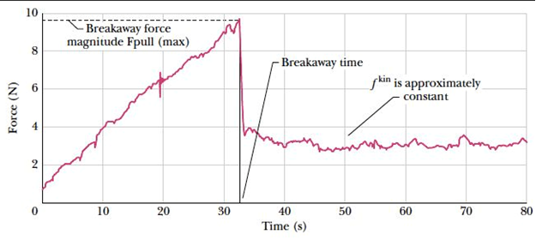

* Which force value should we record?
* There are clearly two sections to the force graph, what do these sections represent?
  + Students should be directed to consider the motion of the block during that time.

The annotation on the graph above:

* The static friction force that we want to record is the MAXIMUM value.
* The kinetic friction force that we want is the MEAN value of the ‘flat’ area.

### Performance Notes

It should be stressed to the students that they need to ensure that they get a graph VERY similar to the example graph above in order to record the data. 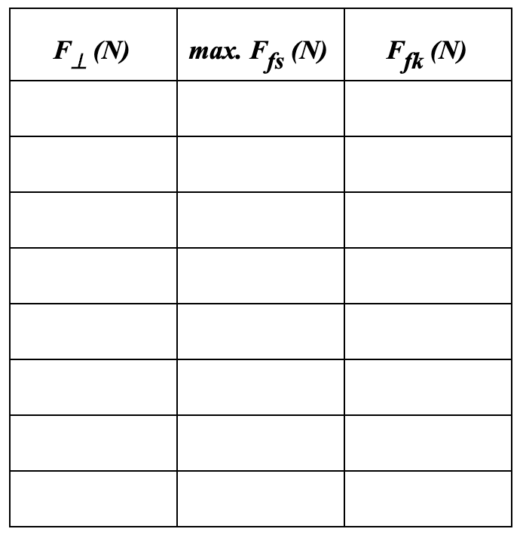

The perpendicular force can be changed by adding more mass to the wooden block.

The data table should match what is shown to the right. BOTH the static and kinetic friction should be graphed against the perpendicular force.

### Post-Lab Discussion

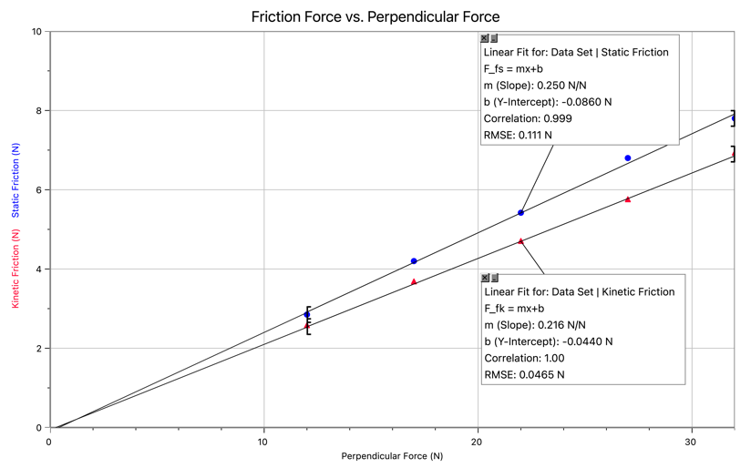After completing the data collection, the graph of friction force vs. perpendicular force should be similar to what is shown to the right.

It should be noted that the slope for the kinetic friction force is greater than the static friction force.

It should be noted that the static friction force graphed is the MAXIMUM, not the actual friction value for all static situations.

**Kinetic friction: $F_{fk}=μ_{k}F_{⊥}$**

**Static friction: $F_{fs}≤μ_{s}F_{⊥}$**

Please note the equation for the static friction is an inequality, not an equal sign. The static friction can be ANY magnitude UP TO the maximum value. This is similar to the perpendicular force, which can be any number, up to the breaking point of the surface. Thin ice is a good example to discuss regarding the limit to the normal force.

## Worksheet 4 — Friction Force

### Resources

* Unit 4 Worksheet 4: Friction Force

Students practice calculating friction force, based on the expressions just investigated.

## Worksheet 5 — Forces in Equilibrium

### Resources

* Unit 4 Worksheet 5: Forces in Equilibrium

This worksheet gives students an opportunity to work through equilibrium problems. Students will practice:

* system schemas
* Force Diagrams
* writing summation equations for vertical and horizontal directions
* solving for various unknowns (specific forces, mass, etc.)

Question 4 offers an opportunity to begin the introduction of the **“megadot” concept (multiple object system).**

In this scenario, the problem becomes *much* easier to solve if the 7 kg and 4 kg objects are thought of as a single entity, which we will refer to as a “*megadot*.” Be sure that students draw the full system schema, illustrating the two objects separately, and have them work out the force diagrams for EACH object separately.

Afterwards, show that the force diagram for the 4 kg object provides all the information needed to solve for the tension in the bottom string.

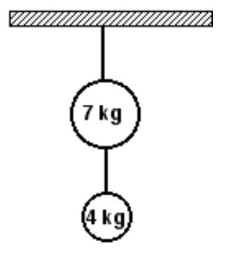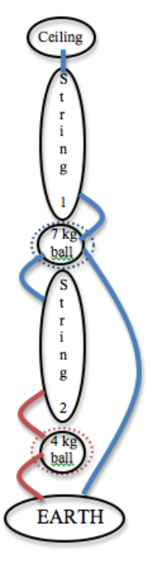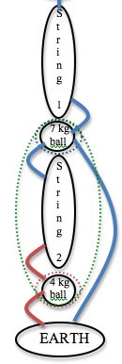

original diagram

separate systems

“Megadot” system

F

t by s2 on 7

g by E on 7

F

F

t by s1 on 7

t by s2 on 4

F

F

g by E on 4

g by E on MD

F

t by s1 on MD

F

Solving for the tension in the top string is more complicated, requiring action/reaction pairs on the bottom string. Using the “megadot,” where the 7 kg and 4 kg objects are one entity, a single force diagram can show that the tension in the top string is due to the weight of both masses.

In this case, there are two forces acting on the new green “megadot” system – one force of tension (the top string), and one force of gravity *for the system* as illustrated.

Then, the force diagram for determining the tension in the top string is the same as the force diagram for the bottom string.

There is a bit more effort required to develop this “megadot” concept, but the pay off in the future to tackle far more complicated situations is well worth the time to develop it.

## Activity 5 — Rocket Lander Game

### Resources

* Students’ saved Rocket Lander game (starter code at <https://tinyurl.com/Rocket-Lander-Game>)
* Unit 4 Activity 5: Rocket Lander Game

At this point, students can add a function to set the game status, or message at the top of the screen.

Students use their saved file from Google Drive.

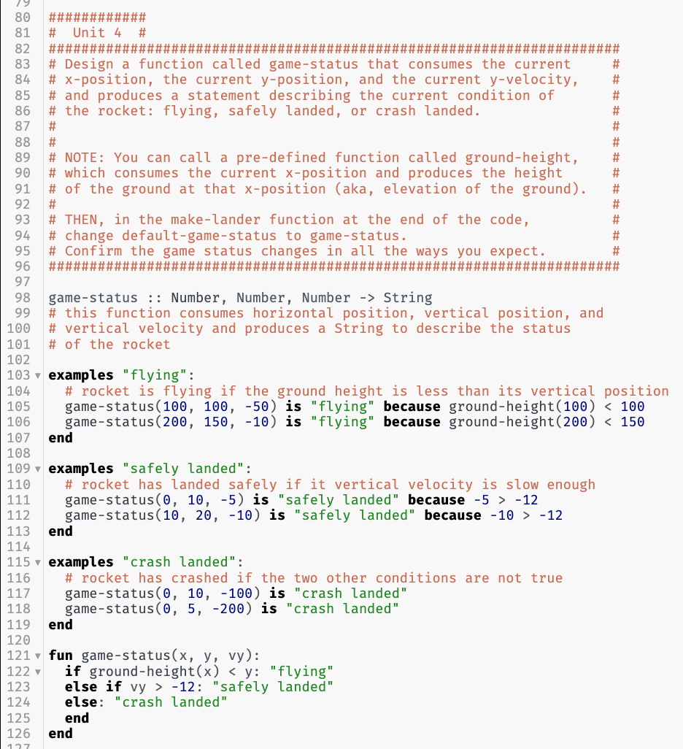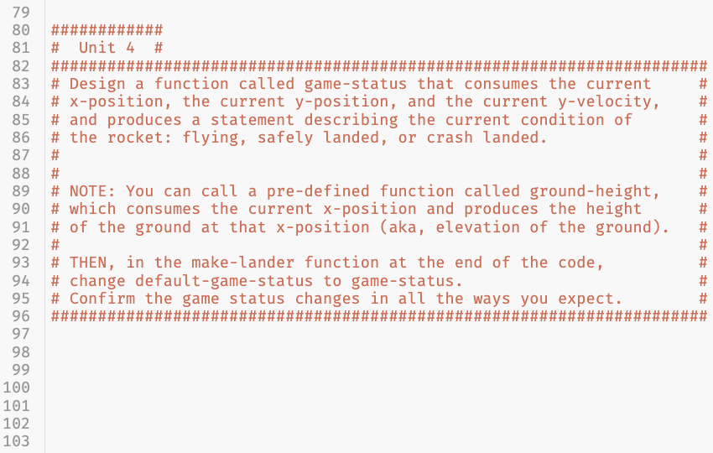

The game-status function takes in the current state of the rocket (horizontal position, vertical position, and vertical velocity) and produces a string. The function ground-height consumes the horizontal position of the rocket and produces the height of the ground at that x position, also known as elevation. This can be used to determine if a crash has occurred. Students can personalize the conditions and the desired outputs.

## The Model So Far

To summarize the unit, students should create “The Model So Far,” the current model for the motion of an object. The goal is to both review representations of motion and assess student understanding of the current model before progressing to forces.

# 

# **Resource Index**

1. Unit 4 Reading 1: Forces
2. Unit 4 Worksheet 1: Force Diagrams
3. Unit 4 Reading 2: Force Diagrams
4. Unit 4 Activity 2: Ball-Sand-Fan Simulation
5. Unit 4 Activity 3: Air Hockey Table
6. Unit 4 Worksheet 2: Air Hockey Table Analysis
7. Unit 4 Activity 4: Pairs of Forces
8. Unit 4 Worksheet 3: Pairs of Forces
9. Unit 4 Lab 2: Friction Force
10. Unit 4 Worksheet 4: Friction Force
11. Unit 4 Worksheet 5: Forces in Equilibrium
12. Unit 4 Activity 5: Rocket Lander Game
13. Function Design with Conditionals

#### Unit 4 Reading 1: Forces

**Types of Forces and Force Representation**

In this unit, we define a **force** as *any interaction between two objects that results in a directional push or pull on an object*. We use the symbol $\overset{⃑}{F}$ (the capital letter F with an arrow above it) to denote a force.

Despite the seemingly wide variety of pushes and pulls we experience every day as humans, there are only four distinct types of forces that occur in nature. Of these, only two are a part of our everyday experience. These four “fundamental interactions” are:

**The Gravitational Force**

A gravitational force exists between any two objects that have mass. It is always an attractive force, pulling each object toward the other along the line that connects their centers. This force is very weak unless at least one of the objects is very, *very* massive (this is why you don’t notice that you are attracting your pencil, another person, or anything else). The only noticeable gravitational interaction we notice is the one between the earth and other objects.

**The Electromagnetic Force**

An electromagnetic force exists between any two objects that have electric charge. This force can be attractive or repulsive, because charge comes in two varieties: positive and negative. Whenever two objects have opposite charges (positive and negative), they will produce an attractive force on each object, similar to the gravitational force. Whenever two objects have the same kind of charge, however (either both positive or both negative), they will repel each other.

Nearly every push or pull that you are likely to think of that is not gravitational is fundamentally an electromagnetic interaction. When you push on a cart, for instance, it is the interaction of the negative charge surrounding the atoms in your hands repelling the negative charge surrounding the atoms in the handle of the cart.

**The Strong and Weak Nuclear Forces**

The strong and weak nuclear forces have to do with holding the nuclei of atoms together and with radioactive decay, and don’t appear in ways that are noticeable in our everyday lives.

Therefore, we can describe most of the forces we notice as either *gravitational* or *electromagnetic* interactions. Because we can see them with the naked eye, these are called *macroscopic forces*.

**Macroscopic Forces**

Electromagnetic forces are involved in every other interaction (force) that we deal with in our everyday life. There are so many ways for objects to interact electromagnetically, that it is helpful to give various electromagnetic interactions their own names. For instance, when surfaces rub on each other, or flow (as in liquids and gases) past objects, there is an electromagnetic interaction we sometimes call *friction* or *drag*. When an object rests on a horizontal surface and pushes down, that surface pushes back upwards on the object as a result of an electromagnetic interaction. We call this a perpendicular, or *normal*, force. When a string or rope pulls on an object, we call this chain of electromagnetic interactions a *tension* force. The list of common forces that fit into the electromagnetic category goes on and on.

**Force Notation**

Any directional push or pull (force) will begin with the symbol $\vec{F}$ for force. We will then follow the $\vec{F}$ with a *subscript* that denotes the type of interaction.

If the interaction is *gravitational*, like the earth pulling down on a person or other object, we will use the symbol ***g*** as a subscript. If the interaction is a *frictional* force, we will use a subscript ***f***. A *tensional* force applied by a rope, string or other similar material will use a subscript ***T***. The support force from a surface, known as a *normal* force, will use a subscript $⊥$. Since there are so many other ways to classify other forces, we will call any other interaction just a *push* or a *pull* for now and will use the subscript ***A*** to denote a generic applied push or pull.

There are two more subscripts that we will add to the end of this notation, denoting the two objects that are interacting. The first object listed is the object exerting the force - the “agent” or “dealer” of the force (i.e., the “pusher” or “puller”). The second object listed is the object experiencing the force - the “object” or “feeler” of the force (i.e., the “pushed” or “pulled”).

The symbol for the force would therefore contain $\vec{F}$ for force, followed by ***T*** for the *type* of force, followed by ***A*** for the *agent* of the force, followed by ***O*** for the *object* of the force.

$${\vec{F}}_{T by A on O}$$

This order of the final two subscripts is sometimes called “agent/object” notation, or “by/on” notation. The dealer of the force is the agent, or the object that is exerting the force - the object that the force is “by.” The feeler of the force is the object, or the object that is experiencing the force - the object that the force is “on.”

* The gravitational force on a person by the earth would be denoted ${\vec{F}}_{g by E on P}$
* The frictional force on a car by the road could be denoted ${\vec{F}}_{f by R on C}$
* The pull of a rope upwards on a bucket might be represented as ${\vec{F}}_{T by R on B}$
* The upward push on a person by the floor might be represented as ${\vec{F}}_{⟂ by F on P}$
* The push on a wall by a person might be represented as ${\vec{F}}_{A by P on W}$

Visually, we will represent forces with an arrow. Since we are concerned about two major aspects of a force, magnitude (size) and direction, arrows work nicely for this. We can represent the magnitude of the force by how long we draw the arrow, and the direction of the force by which way we point the arrow.

Consider the gravitational force by the earth on a 180-pound teacher, and the gravitational force by the earth on a 90-pound student. Since the gravitational interaction between the teacher and the earth is attractive, the gravitational force by the earth on the teacher is toward the center of the earth, which is defined as ‘downward.’ The same is true of the gravitational force by the earth on the student. The graphical representations of these forces would be as follows:

F

g by E on T

g by E on S

F

Notice that the two arrows point down since the gravitational force is downward. Notice also, that the arrow for the teacher is twice as long as the one for the student since the gravitational force is twice as strong on the teacher.

#### Unit 4 Worksheet 1: Force Diagrams

For each of the following underlined systems:

1. Draw the system schema for the object or objects included in the system.
2. In the box to the right of the physical diagram, draw a force diagram for the specified object in each of the following situations.
   1. Represent the object as a particle by drawing a dot in the middle of the blank.
   2. Draw each of the forces acting on the object, making the length of each vector represent the magnitude of the force.
   3. Label each force using the system discussed in class. Specifically, each force should be labeled with a capital F, followed by a subscript which describes the type of force, followed by two subscripts which describe the “agent” of the force and the “object” of the force.
3. Specify sign conventions for the vertical and horizontal directions.
4. Define subscripts by indicating the type of force, the agent and the object.
5. Write expressions for the sum of forces on your system in both the horizontal and vertical directions.

Use the following symbols for the various forces:

Fg Gravitational force

F⟂ Perpendicular force

FT Tension force

Ff Frictional force

FA Applied force

Force

What the force is “on”

The “object” of the force

What the force is “by”

The “agent” of the force

Type of force

F

T

by Agent on Object

|  |  |  |
| --- | --- | --- |
| 1. A bird sitting motionless on a perch. | Force Diagram: | Sign Conventions: |
| Sum of Forces Equation(s): $$\sum{F_{x}}=$$ $$\sum{F_{y}}=$$ |
| System Schema: |
| Subscript Definitions: |
| 1. Draw a force diagram for a hockey player, moving at a constant velocity, across frictionless ice. | Force Diagram: | Sign Conventions: |
| Sum of Forces Equation(s): $$\sum{F_{x}}=$$ $$\sum{F_{y}}=$$ |
| System Schema: |
| Subscript Definitions: |
| 1. Draw a force diagram for a baseball player who slows as he slides into the base. | Force Diagram: | Sign Conventions: |
| Sum of Forces Equation(s): $$\sum{F_{x}}=$$ $$\sum{F_{y}}=$$ |
| System Schema: |
| Subscript Definitions: |

|  |  |  |
| --- | --- | --- |
| 1. Draw a force diagram for the chandelier which is suspended from the ceiling by a chain. | Force Diagram: | Sign Conventions: |
| Sum of Forces Equation(s): $$\sum{F_{x}}=$$ $$\sum{F_{y}}=$$ |
| System Schema: |
| Subscript Definitions: |
| 1. Draw a force diagram for the bucket of water that is being raised from the well at a constant velocity. | Force Diagram: | Sign Conventions: |
| Sum of Forces Equation(s): $$\sum{F_{x}}=$$ $$\sum{F_{y}}=$$ |
| System Schema: |
| Subscript Definitions: |
| 1. Draw a force diagram for a skydiver who has just left the plane and is accelerating toward the ground. | Force Diagram: | Sign Conventions: |
| Sum of Forces Equation(s): $$\sum{F_{x}}=$$ $$\sum{F_{y}}=$$ |
| System Schema: |
| Subscript Definitions: |
| 1. Draw a force diagram for a skydiver who has opened the parachute and is descending at a constant velocity. | Force Diagram: | Sign Conventions: |
| Sum of Forces Equation(s): $$\sum{F_{x}}=$$ $$\sum{F_{y}}=$$ |
| System Schema: |
| Subscript Definitions: |
| 1. Draw a force diagram for the basketball in the middle of a free throw. | Force Diagram: | Sign Conventions: |
| Sum of Forces Equation(s): $$\sum{F_{x}}=$$ $$\sum{F_{y}}=$$ |
| System Schema: |
| Subscript Definitions: |
| 1. Draw a force diagram for a hurdler as she clears a hurdle. | Force Diagram: | Sign Conventions: |
| Sum of Forces Equation(s): $$\sum{F_{x}}=$$ $$\sum{F_{y}}=$$ |
| System Schema: |
| Subscript Definitions: |
| 1. Draw a force diagram for an airplane flying at a constant velocity in level flight. | Force Diagram: | Sign Conventions: |
| Sum of Forces Equation(s): $$\sum{F_{x}}=$$ $$\sum{F_{y}}=$$ |
| System Schema: |
| Subscript Definitions: |
| 1. Draw a force diagram for the water skier moving at a constant velocity. | Force Diagram: | Sign Conventions: |
| Sum of Forces Equation(s): $$\sum{F_{x}}=$$ $$\sum{F_{y}}=$$ |
| System Schema: |
| Subscript Definitions: |

#### Unit 4 Reading 2: Force Diagrams

**Force Diagrams and System Schema**

A proper force diagram will include the following elements:

* A system schema that shows the object(s) that make up the system being analyzed.
* A dotted line around the object(s), which denotes the elements of the system.
* Each connection on the system schema becomes an arrow on the force diagram.
* An arrow of appropriate length, in the proper direction to represent each force.
* An appropriate label for each force.
* All force arrows should start at the center of the object.

Changes

in Velocity

Forces

infer

deduce

Force Diagrams can depict situations where the forces are *balanced* and situations where the forces are *unbalanced*. In this section we will explore the relationship between motion and these force situations that are responsible for them.

In other words, by identifying the type of motion we are dealing with, we can determine whether the forces are balanced or unbalanced. Or, in reverse, if we know the forces are balanced or unbalanced, we can determine the type of motion.

There are five major motion situations that we will deal with in this unit. These include:

1. Objects at rest (balanced forces).
2. Objects moving at a constant speed in a straight line (balanced forces).
3. Objects that are speeding up (unbalanced forces).
4. Objects that are slowing down (unbalanced forces).
5. Objects that are changing direction (unbalanced forces).

**Situations 1 & 2: Objects at rest and objects undergoing uniform motion**

Objects at rest and objects undergoing uniform motion are both examples of objects that experience no unbalanced force. In other words, the forces acting on an object must be balanced for an object to be at rest or for one to move at a constant speed in a straight line (aka, constant velocity).

**Balanced Force Diagrams**

A hover puck sits perfectly still on a perfectly level surface with the fan turned off. The earth pulls downward on it with a gravitational force. We denote this force as ${\vec{F}}_{g by E on p}$. The puck doesn’t fall as a result of this force, so there must be a force balancing the gravitational force. That force is from the table pushing upward on the puck. We denote the upward push on the puck by the table ${\vec{F}}_{⟂ by T on P}$ 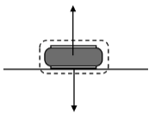

The pictorial diagram for this situation must show the puck and the floor. Superimposed on the pictorial diagram, is the force diagram. The two forces acting on the object are the same magnitude, but act in opposite directions, so they are balanced. Mathematically, this means that their sum is zero. Therefore, the sum of the forces (or ‘net force’) acting on the puck is zero.

*What happens to the force diagram if the fan is now turned to the on position?* If the surface on which the puck is placed is truly level, the puck will hover motionless on a cushion of air. The gravitational force, ${\vec{F}}_{g by E on p}$, will not change. The air instead of the table now provides the upward force. This new force, the upward push on the puck by the air is denoted ${\vec{F}}_{A by a on p}$. 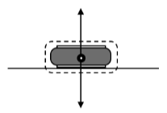

The force diagram looks exactly the same as before, except for the label on the upward force. The unbalanced force on the puck is zero, just as it was when the puck was resting on the table with the fan turned off.

Let us now assume that the puck is already moving to the right (How it started moving is outside our observation window, so we cannot concern ourselves with that). What forces act on the puck now? Interestingly, the force diagram is identical to the previous situation. The puck experiences only the downward force of gravity due to the earth ${\vec{F}}_{g by E on p}$, and the upward force on the puck by the air ${\vec{F}}_{A by a on p}$. The forces remain balanced. And so, mathematically the unbalanced force (net force) on the puck is still zero.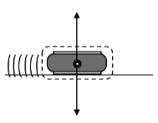

The most important thing to understand about this situation is that the puck will, as long as the forces remain balanced, travel at the same speed in a straight line. Nothing is required to cause the puck to keep moving. An unbalanced force would be required to cause it to go faster or slower, and/or an unbalanced force would be necessary to change its direction. But in the absence of an unbalanced force, the puck will continue to move in a straight line at a constant speed.

**Force Diagrams when the Unbalanced Force is Non-Zero: Speeding Up**

Consider a hover puck, with the fan turned on, which is at rest on a level surface but has a person pushing it to the right. The downward force of gravity on the puck, ${\vec{F}}_{g by E on P}$, and the upward push of the air on the puck, ${\vec{F}}_{A by A on P}$, still act on the puck. Additionally, the person is exerting a force (by pushing with their hand) on the puck to the right. Let’s call that force ${\vec{F}}_{A by H on P}$. Since the first two forces, ${\vec{F}}_{g by E on P}$ and ${\vec{F}}_{A by A on P}$, are *balanced*, the remaining force, ${\vec{F}}_{A by H on P}$, is the *unbalanced* force. The result of this *unbalanced* force, or any *unbalanced* force for that matter, is that the object in question will accelerate. This is to say that the object will speed up, slow down, or change directions. In this case, the *unbalanced* force will cause the object to begin to move in the direction of the force. After it starts moving, the *unbalanced* force acts in the same direction as the object is moving and the result is that the object will speed up. Anytime the *unbalanced* force on an object acts in the same direction the object is traveling, the object will speed up in the direction of the net force.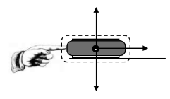

If we were to make a movie of the puck from overhead while the puck was being pushed, the frames of the movie would look something like this (minus the arrows).



The arrows above the images of the puck are intended to convey the changing speed of the puck. In this case the length of the arrows represents the speed of the puck and the direction the arrows point represents the direction the puck is moving.

***The big idea here is simple: Whenever an object experiences an unbalanced force in the same direction it is moving, it will speed up!***

**Force Diagrams when the Unbalanced Force is Non-Zero: Slowing Down**

Now let’s consider a different situation. In this case, the puck (fan turned on) is already moving to the right. A person pushes the puck to the left, while it is moving toward her. Remember, the puck is moving to the right while being pushed to the left. How will this affect the motion of the puck? Analysis of the force diagram indicates that the *unbalanced* force is ${\vec{F}}_{A by H on P}$. In this case, and any time the direction of the *unbalanced* force is opposite the direction of motion, the object will slow down. The video analysis of the puck would look something like this: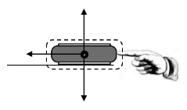



Notice that the images of the puck are getting closer together, indicating that the puck is slowing down. The arrows, indicating velocity, are getting shorter as well.

***Big idea: Whenever an object experiences an unbalanced force opposite the direction it is moving, it will slow down!***

#### Unit 4 Activity 2: Ball-Sand-Fan Simulation

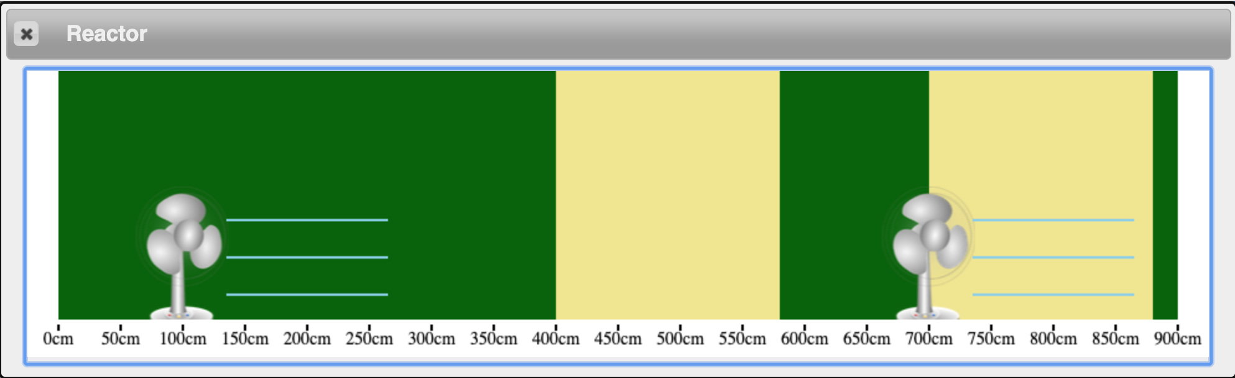

In this simulation a ball moves across the screen with some initial positive velocity. When it is in the area marked with three lines (between 100 cm and 280 cm, and between 700 cm and 880 cm) the wind from the fan gives it an applied force to the right. When it is in the lighter-colored areas (between 400 and 580 cm, and between 700 and 880 cm), there is a resistive force from the sand.

1. The ball starts at an initial position of 0 cm and moves to the right. Draw and label a motion map for the ball. (*Be sure to include both velocity and acceleration vectors.*)

0 100 200 300 400 500 600 700 800 900

**+ x**

**(cm)**

2. Look at the acceleration vectors on your motion map. During which portions of the map does the ball have a constant velocity? What can you say about the sum of the forces for these portions? Draw a force diagram and a sum of forces equation.

3. During which portion(s) is the ball accelerating to the right? What can you say about the sum of the forces for this portion? Draw a force diagram and a sum of forces equation.

4. During which portion(s) is the ball accelerating to the left? What can you say about the sum of the forces for this portion? Draw a force diagram and a sum of forces equation.

5. Complete a Function Design for the function sum-of-forces which takes in sand-force and fan-force and returns a String that describes the condition of the sum of the forces on the ball.

When you have completed this, open the simulation at <https://tinyurl.com/U4-Ball-Sand-Fan>.

#### Unit 4 Activity 3: Air Hockey Table

**Broken Air Hockey Table – Pyret Simulation**

The left side of this air hockey table is working as intended (*frictionless*), and the right side is not, so it has friction. Go to the code for the simulation at <https://tinyurl.com/U4-Air-Hockey>.

The friction on the right side is already present (you do not have to code it). Your goal is to write a conditional function called My-Force that keeps the puck moving the entire time as if both sides of the air hockey table were working (meaning that the air jets are on, and the puck is moving at constant velocity). The contract for your function is:

My-Force :: Number -> Number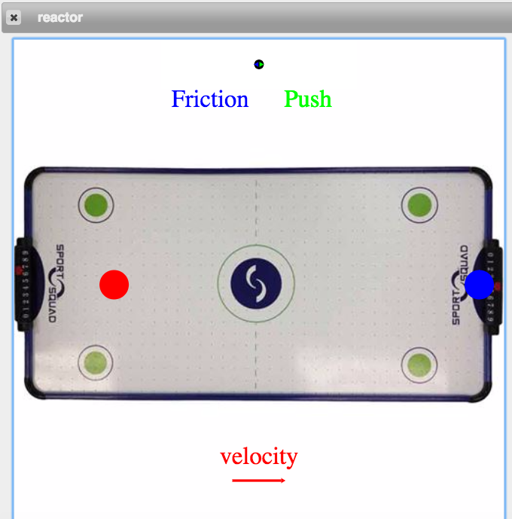

Please note that there is a blue ‘goalie’ paddle blocking the path of the puck. The paddle will be ‘lifted’ out of the way, if you:

1. Correctly write the conditions. Use a Function Design with Conditionals to do so.
2. Provide the correct amount of force to balance the friction conditions.

If not, the blue ‘goalie’ will block your path OR crash down on top of the puck, stopping it.

#### Unit 4 Worksheet 2: Air Hockey Table Analysis

For each of the situations described below, draw a physical diagram, the system schema, and the corresponding force diagram for the hockey puck from your Pyret simulation. Assume that the “object” in each case is the air hockey puck. Include the air hockey puck, the “agent” pushing the air hockey puck, and the table in the system. Assume that the friction between the air hockey puck and the table is negligible unless the problem states otherwise.

1. The air hockey puck is moving on the left side, before there is any “friction.”

|  |  |  |
| --- | --- | --- |
| Physical Diagram | System Schema | Force Diagram |

1. The air hockey puck is moving on the right side, while there is “friction.”

|  |  |  |
| --- | --- | --- |
| Physical Diagram | System Schema | Force Diagram |

1. Show the air hockey puck as it moves across the midpoint boundary of the table.

|  |  |  |
| --- | --- | --- |
| Physical Diagram | System Schema | Force Diagram |

#### Unit 4 Activity 4: Pairs of Forces

For each of the scenarios that follow, you will be measuring the magnitude of the forces two objects exert on one another. In other words, if we label one object as Object A and the other as Object B, you are measuring the force by Object A on Object B and the force by Object B on Object A.

Begin by checking that both force sensors have a reading of zero Newtons when no force is applied. Label one “Object A” and the other “Object B.”

1. Objects A and B are connected by a string.

Tie a knot in a length of string to make a loop. Place this loop through the hook of each force sensor and pull them apart. Record your findings in the table below.

|  |  |  |
| --- | --- | --- |
| System Schema | Force Diagram for Object A | Force Diagram for Object B |
| Force vs. Time graph | How do the forces compare? Why do you think this happens? | |

2. Objects A and B hold magnets and push one another.

Place a magnet on the end of each force sensor and push them toward one another. Record your findings in the table below.

|  |  |  |
| --- | --- | --- |
| System Schema | Force diagram for Object A | Force diagram for Object B |
| Force vs. Time graph | How do the forces compare? Why do you think this happens? | |

3. Object A pushes Object B on a level surface.

Switch the hooks of the force sensors for the rubber bumpers. Secure each force sensor to the top of a dynamics cart. Place the carts on a dynamics track and push Object A so that it pushes Object B. Record your findings in the table below. *The rubber bumpers should be touching one another.*

|  |  |  |
| --- | --- | --- |
| System Schema | Force diagram for Object A | Force diagram for Object B |
| Force vs. Time graph | How do the forces compare? Why do you think this happens? | |

4. Lighter Object A pushes heavier Object B on a level surface.

Place extra masses in Object B’s cart and push Object A so that it pushes Object B. Record your findings in the table below.

|  |  |  |
| --- | --- | --- |
| System Schema | Force diagram for Object A | Force diagram for Object B |
| Force vs. Time graph | How do the forces compare? Why do you think this happens? | |

5. Object A pushes Object B uphill.

Elevate one end of the dynamics track and push Object A so that it pushes Object B up the incline. Record your findings in the table below.

|  |  |  |
| --- | --- | --- |
| System Schema | Force diagram for Object A | Force diagram for Object B |
| Force vs. Time graph | How do the forces compare? Why do you think this happens? | |

6. Object A pushes Object B downhill.

Switch the direction and push Object A so that it pushes Object B down the incline. Record your findings in the table below.

|  |  |  |
| --- | --- | --- |
| System Schema | Force diagram for Object A | Force diagram for Object B |
| Force vs. Time graph | How do the forces compare? Why do you think this happens? | |

#### Unit 4 Worksheet 3: Pairs of Forces

For each of the scenarios below:

1. Draw a system schema. Include all important objects in your system.
2. Identify the force pairs, and list them using agent-object notation.
3. Construct a force diagram for each underlined object.

|  |  |
| --- | --- |
| 1. One book lies on top of a second book, which rests on a table. | Force Pairs: |
| System Schema: | Force Diagrams: |

|  |  |
| --- | --- |
| 1. A person exerts an upward force of 40 N to hold a bag of groceries. | Force Pairs: |
| System Schema: | Force Diagrams: |

|  |  |
| --- | --- |
| 1. A magnet is suspended from the ceiling by a string. A second magnet is held up by the first magnet. | Force Pairs: |
| System Schema: | Force Diagrams: |

1. A person sits in a chair, perfectly still. Draw separate force diagrams for the person, the chair, and the whole earth. Show the relative sizes of the forces. Identify all force pairs.
2. 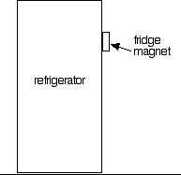A magnet is attached to the front of a refrigerator.
   1. Draw a system schema for this situation.
   2. Draw separate force diagrams for the magnet, the refrigerator, and the floor. Identify all force pairs.
3. Imagine you are standing on the ground and jump straight up. For each moment described:
4. Draw a state diagram of the situation at that moment
5. Draw separate force diagrams for the jumper and the earth
6. Label any force pairs that occur in your diagrams
7. You are bent down: your legs are flexed and pushing on the floor. Your body is being accelerated upward, but you have not yet left the ground.
8. Your body leaves contact with the floor, and you are moving up through the air.
9. You reach the top of the jump.
10. You begin falling but have not yet reached the ground.
11. Repeat for the situation just after you hit the ground and your bent legs are slowing you down.
12. 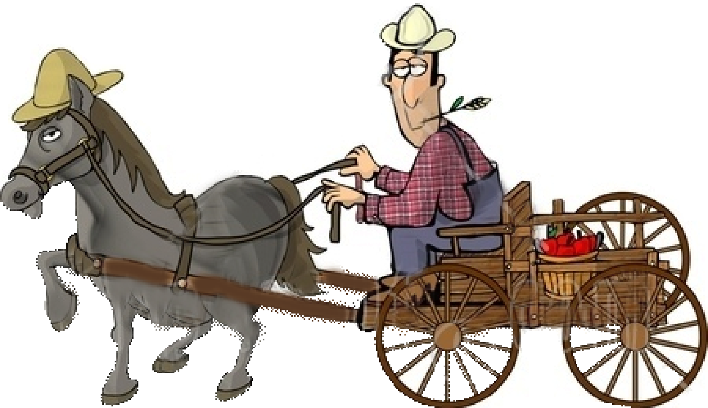A farmer hitches a horse to a wagon, intending to have it pull them along the road. A bystander remarks, “There is no way your horse can pull that cart. If it pulls on the wagon, the wagon will pull back on the horse just as hard. The forces will cancel, and you won’t be able to move.”
13. Draw a force diagram for a system that consists of only the wagon, just as it begins to be pulled by the horse. Explain how it is possible for the wagon to change velocity.
14. Draw a force diagram for a system that consists of only the horse, just as it begins to pull the wagon. Explain how it is possible for the horse to change velocity.
15. Draw a force diagram for a system that includes both the horse and the cart, just as the horse begins to pull the cart. Explain how it is possible for the whole system to change velocity.
16. Explain the flaw in the bystander’s reasoning about force pairs.
17. For each situation shown below, draw a force diagram for block A, a force diagram for block B, and a force diagram for a system that includes both blocks.

a.

constant **v**

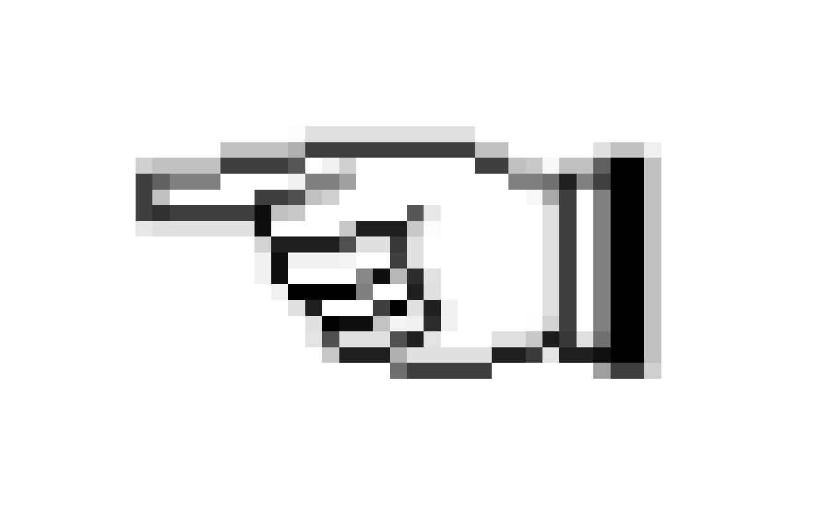

**A**

**B**

50 g

50 g



b.



**B**

50 g

constant **a**

**A**

50 g

c.

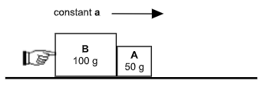

#### 

#### Unit 4 Lab 2: Friction Force

1. Be sure that you get a graph similar to the one shown to the right, before keeping your data and then record your values on the table below.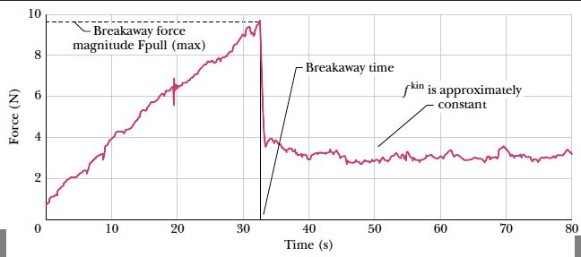

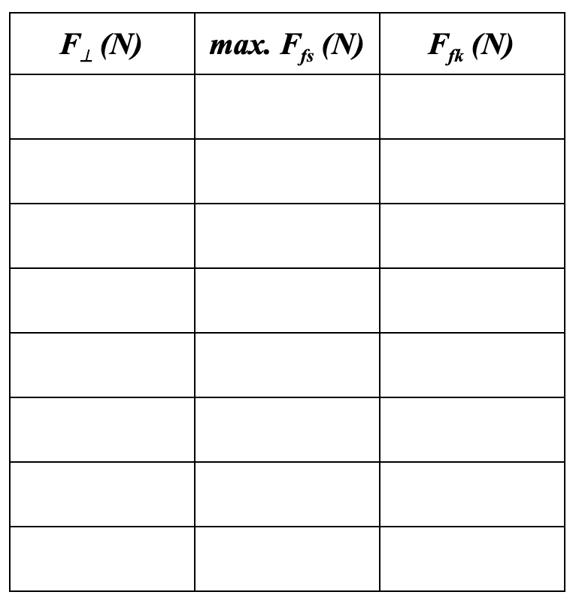

1. Determine the slope of the line for the kinetic (moving) friction force. (Show your work.)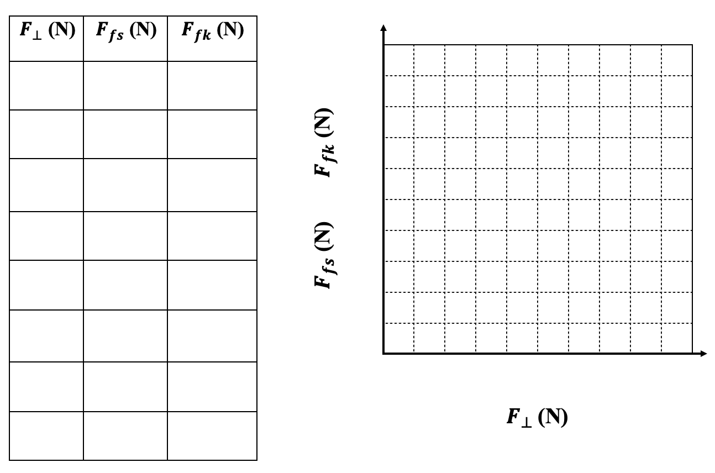
2. Determine the slope of the line for the static (stationary) friction force. (Show your work)
3. Why is there a difference between the static value and the kinetic value?
4. Based on your experiment, what values are possible for the *static* friction force for a given perpendicular force? Why is there not just one value, like in the kinetic case?

#### Unit 4 Worksheet 4: Friction Force

**Kinetic friction: $F_{fk}=μ_{k}F_{⊥}$** **Static friction: $F_{fs}≤μ_{s}F_{⊥}$**

1. Determine the amount of kinetic friction and the maximum static friction for the following objects:
   1. A 10 kg object on a *flat,* *rough* surface - $μ_{k}$ = 0.60, $μ_{s}$ = 0.75
   2. A 20 kg object on a *flat, smooth* surface - $μ_{k}$ = 0.05, $μ_{s}$ = 0.10
   3. A 10 kg object on a *flat, smooth* surface on the surface of the Moon - $μ_{k}$ = 0.05, $μ_{s}$ = 0.10
2. A horizontal 50.0 N tension force is applied to a 20.0 kg crate moving along a level floor. The coefficient of kinetic friction is 0.15.

a. Draw a force diagram to represent this situation.

b. Does the crate move with a constant or changing velocity? How do you know?

1. In the situation described above, the coefficient of static friction, $μ_{s}$ = 0.25. Is the 50.0 N force sufficient to cause the crate to accelerate? Draw a force diagram, then explain why or why not.
2. A 40.0 kg crate is pulled across a flat surface ( $μ_{k}$ = 0.15, $μ_{s}$ = 0.20) by a force of 100 N. Draw a *quantitative* force diagram for the crate. Is the crate accelerating? How do you know?
3. Why is it easier to *keep* an object moving than it is to *start* an object moving?

#### Unit 4 Worksheet 5: Forces in Equilibrium

For each of the problems below, identify the system using a system schema and then carefully draw a force diagram for the system. After you have drawn the force diagram, determine the required quantities.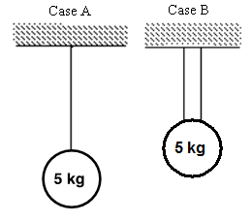

1. Determine the tension in each cable(s) in case A and case B.

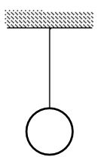

1. The tension in the cable is 100 N. Find the mass of the ball.

1. The tension in the cable on the left is 25.0 N. Find the mass of the ball.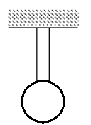
2. Determine tension in each cable. (Hint: There is more than one way to define the system.)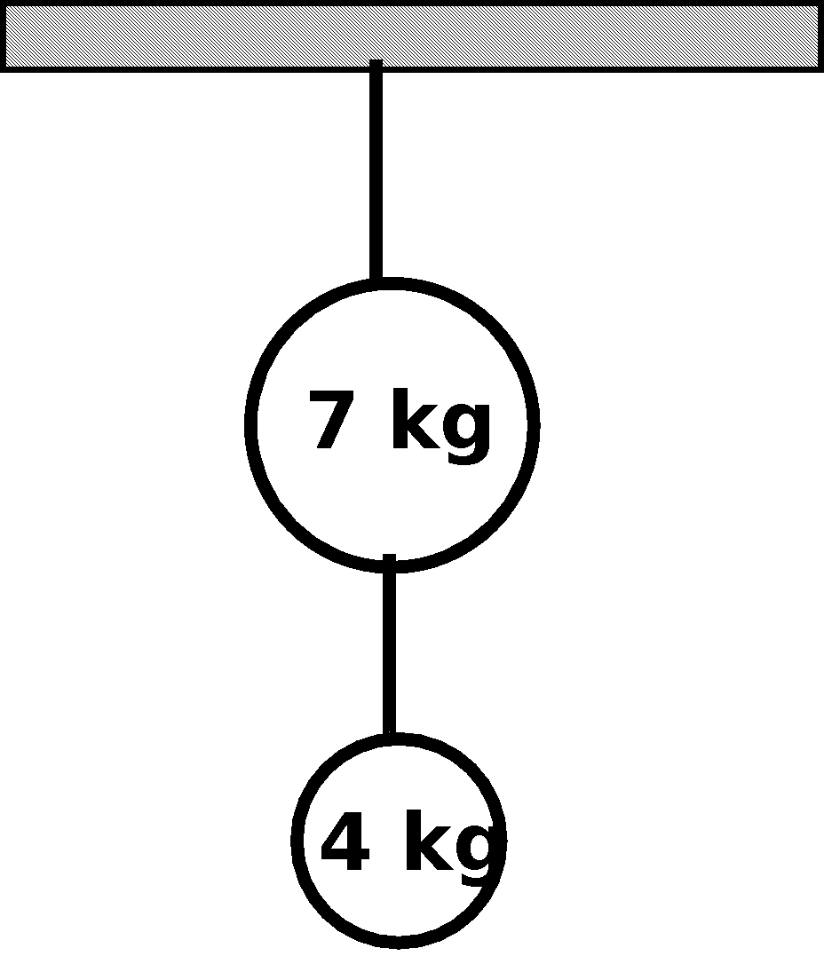
3. The block is sitting at rest on the floor. The normal (perpendicular) force on the block is 3.00 N.
   1. Find the mass of the block.



* 1. What is the weight of the block?

1. A person pushes on a 5.00 kg box with a force of 15.0 N to the right. As a result, the box moves at a constant speed of 10.0 m/s.



* 1. Draw the system schema for this situation.
  2. Draw the force diagram for the box.
  3. Determine the weight of the box.
  4. Determine the normal (perpendicular) force on the box.
  5. Determine the frictional force opposing the motion of the box.
  6. What is the coefficient of kinetic friction?
  7. The person pushes the box from the floor they were on onto the ice of MacGuffin Hockey Stadium. If the coefficient of friction decreases on the ice, what would happen to the box if the person STILL pushes on it with 15.0 N of force? Explain your reasoning.

#### Unit 4 Activity 5: Rocket Lander Game

Previously, you wrote the function next-x, next-y and next-vy to control the motion of the rocket as it lands on the surface of the planet. You have also written an is-onscreen-x function to have the rocket return to the screen if it goes too far. Now, your goal is to write a function game-status that changes the message at the top of the screen based on the current state of the rocket (flying, landed safely on the planet, or crashed into the planet).

1. Open your saved copy of the Rocket Lander Game. Find the following comment block:

############

# Unit 4 #

######################################################################

# Design a function called game-status that consumes the current #

# x-position, the current y-position, and the current y-velocity, #

# and produces a statement describing the current condition of #

# the rocket: flying, safely landed, or crash landed. #

# #

# #

# NOTE: You can call a pre-defined function called ground-height, #

# which consumes the current x-position and produces the height #

# of the ground at that x-position (aka, elevation of the ground). #

# #

# THEN, in the make-lander function at the end of the code, #

# change default-game-status to game-status. #

# Confirm the game status changes in all the ways you expect. #

######################################################################

2. What possible messages would you like to use for each of your game’s statuses?

3. For each game status, what conditions would need to be satisfied?

4. What information would the function game-status need to consume?

5. Complete a Function Design with Conditionals for a game-status function. Once you have a completed Function Design, enter the Contract, Examples, and Definition for the game-status function below the comment above. In the last line, change default-game-status to game-status, and then run the program.

6. Did you receive feedback? Did the code highlighted by the feedback message include your mistake? What did you need to do to make the program run as you intended?

#### 

|  |
| --- |
| Function Design with Conditionals |

|  |
| --- |
| **Defined Identifier(s)** |

|  |  |  |  |  |  |
| --- | --- | --- | --- | --- | --- |
|  | = |  |  | | # |
| Identifier |  | Value | |  | Units |
|  | = |  | |  | # |
| Identifier |  | Value | |  | Units |
|  | = |  | |  | # |
| Identifier |  | Value | |  | Units |

|  |
| --- |
| **Physical Interpretation** |
| What will the input(s) of your function be? _______________________ (ex: side length)  What will the units of each input be? ____________________________ (ex: meters)  What will the output be? ___________________ (ex: area) What are its units? ______________ (ex: m2) |

|  |  |  |  |  |  |
| --- | --- | --- | --- | --- | --- |
| **Contract and Purpose Statement** | | | | | |
|  | | :: |  | -> |  |
| Function Name | |  | Domain (Input) Type(s) |  | Range (Output) Type |
| # |  | | | | |
|  | What does the function do? (The function consumes ______ and produces _______.) | | | | |

|  |  |  |  |  |  |  |  |  |
| --- | --- | --- | --- | --- | --- | --- | --- | --- |
| **Examples** | | | | | | | | |
| **examples** “__________________________________”**:** | | | | | | | | |
|  |  | ( |  | ) | **is** |  | **because** |  | |
|  | Function Name |  | Example Input(s) |  |  | Expected Output |  | What calculation must be performed? | |
|  |  | ( |  | ) | **is** |  | **because** |  | |
| **end** | | | | | | | | |
| |  |  |  |  |  |  |  |  |  |  | | --- | --- | --- | --- | --- | --- | --- | --- | --- | --- | | **examples** “__________________________________”**:** | | | | | | | | | | |  |  | ( |  | ) | **is** |  | **because** |  | |  | Function Name |  | Example Input(s) |  |  | Expected Output |  | What calculation must be performed? | |  |  | ( |  | ) | **is** |  | **because** |  | | **end** | | | | | | | | | | | | | | | | | | |

|  |  |  |  |  |  |  |  |  |
| --- | --- | --- | --- | --- | --- | --- | --- | --- |
| **examples** “__________________________________”**:** | | | | | | | | |
|  |  | ( |  | ) | **is** |  | **because** |  |
|  | Function Name |  | Example Input(s) |  |  | Expected Output |  | What calculation must be performed? |
|  |  | ( |  | ) | **is** |  | **because** |  |
| **end** | | | | | | | | |

|  |  |  |  |  |  |
| --- | --- | --- | --- | --- | --- |
| **Definition** | | | | | |
|  |  |  |  |  |  |
| **fun** | ( ) | | | **:** |  |
|  | Function Name | | Input Name(s) |  |  |
|  | **if** |  | | **:** |  |
|  |  | What must be **true** before the rest of this line is run? | |  | What should happen if the left side is true? |
|  | **else if** |  | | **:** |  |
|  |  | What must be **true** before the rest of this line is run? | |  | What should happen if the left side is true? |
|  | **else:** |  | | |  |
|  |  | What should happen if none of the above lines are true? | | |  |
|  | **end** | | | | |
| **end** | | | | | |

1. D. Hestenes, "Modeling games in the Newtonian World". *Am. J. Phys.* **60** (8), Aug 1992